**DevSecOps Project : Deploying Bingo Application on Kubernetes EKS using DevSecOps Approach**

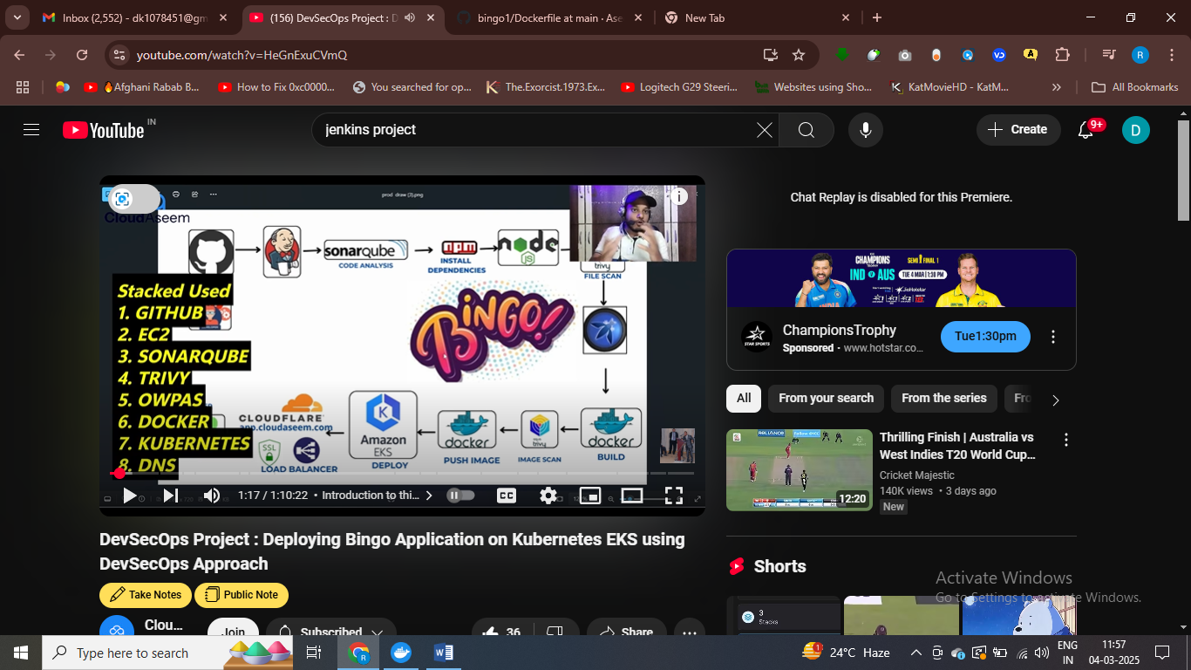

Sonarcube to check standard of code – used for code analysis

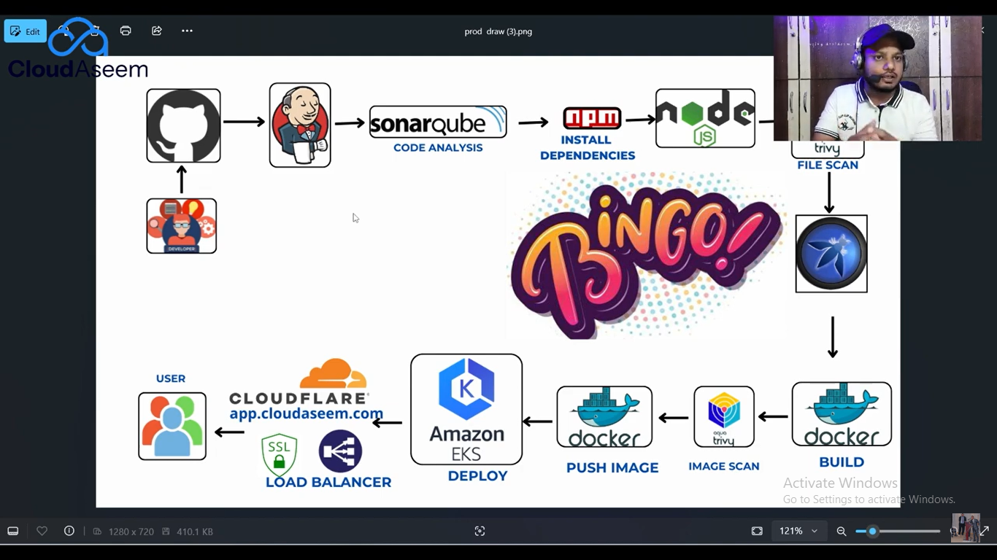

<https://www.youtube.com/watch?v=HeGnExuCVmQ>